The EASiHE (E-Assessment in Higher Education) Project
Civil Engineering Users Introduction - August 2010
David Bacigalupo¹, Bill Warburton¹, Lester Gilbert²
¹MLE Team, iSolutions, ²School of Electronics and Computer Science
University of Southampton SO17 1BJ

Using the System as a Student
The following is an example walk-through.
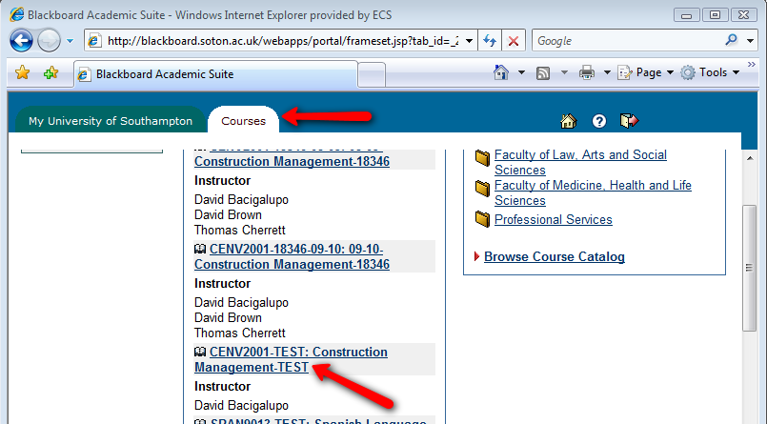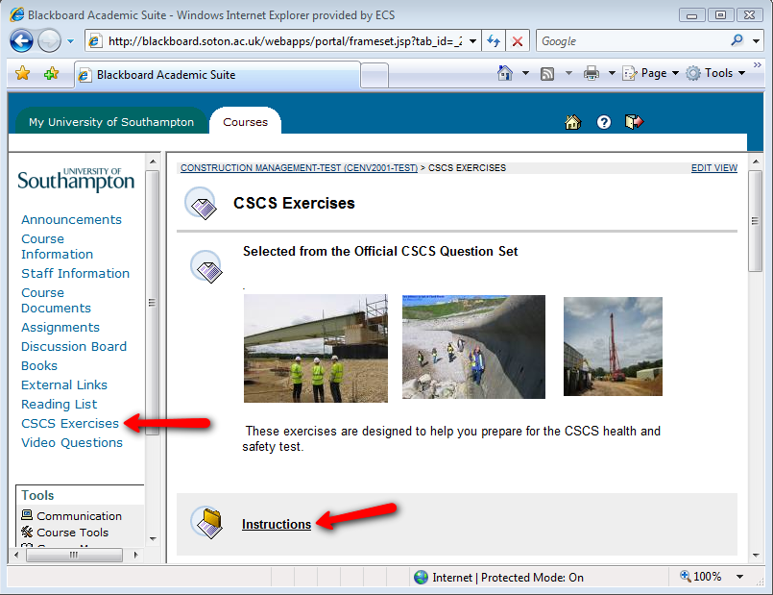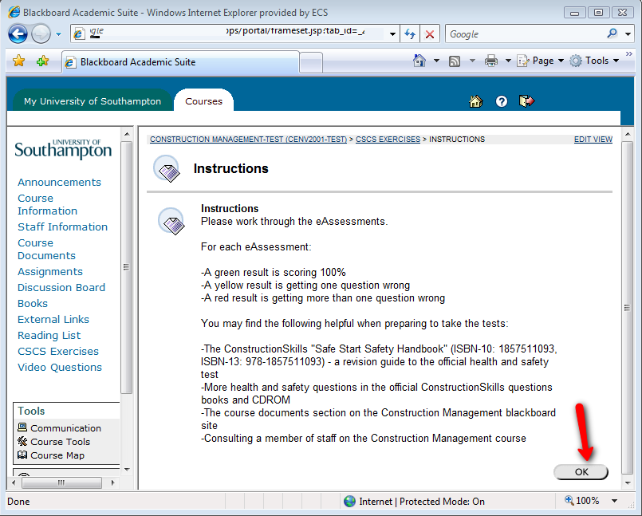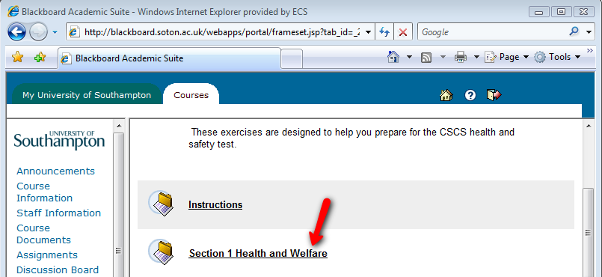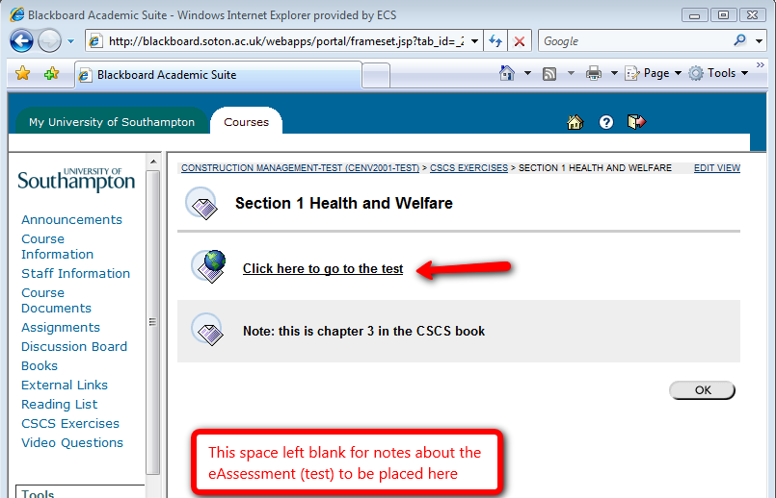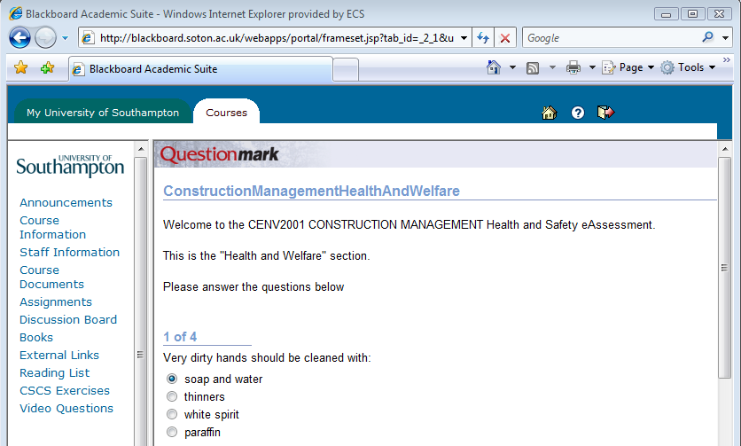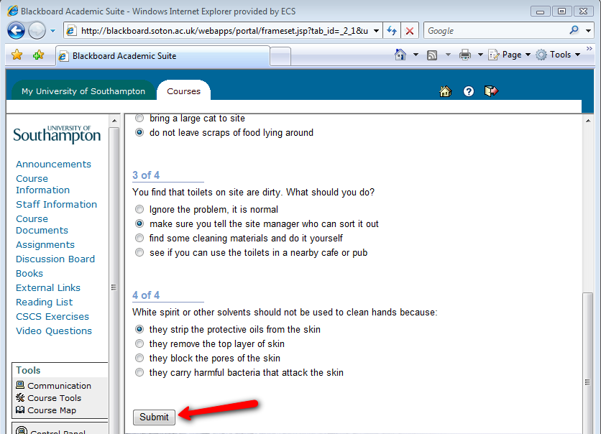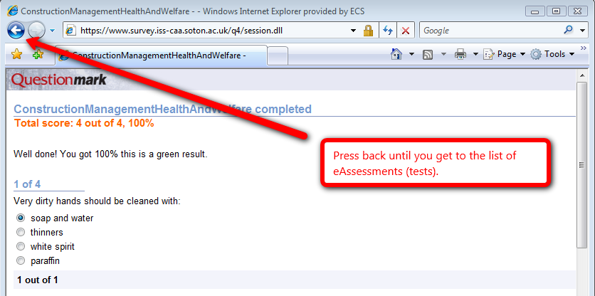
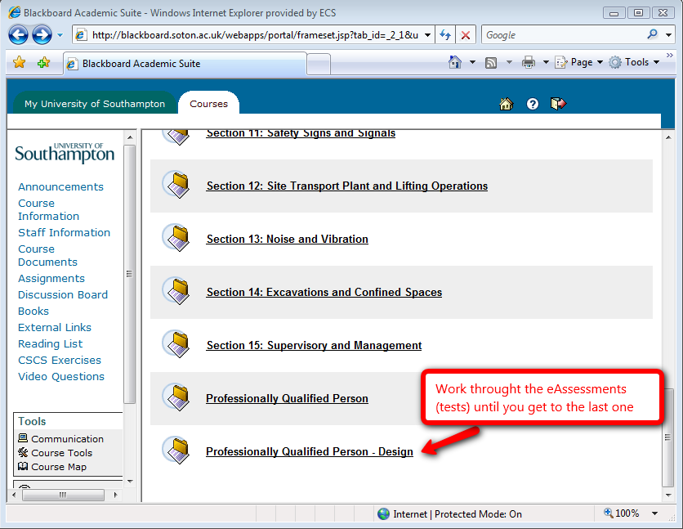

Editing

Perception pages
- Get the name of the assessment you want to edit. This is in the top left hand corner of the assessment as in the previous screenshot.
- Load “Perception authoring manager” which must be installed on your computer.
- If the welcome screen appears cancel it.
- Click on file | open | open shared repository.
- Type in tcp://survey.iss-caa.soton.ac.uk:7800 for the server and click connect.
- Select survey.qmr and click on OK
- Logon using the db1f08 usercode
- Click on “assessments view” at the left hand side of the screen
- The assessments are in folder assessments/db1f08/CivEng
- Double click on an assessment to edit it

Blackboard pages
Click on “edit” in the top right of any screen. This is only available after serviceline gives you editing access.
Table 1 lists all the assessments, how they are accessed and where they are located.

Reporting
- Go to https://www.survey.iss-caa.soton.ac.uk/
- Logon as db1f08
- Click on “enterprise reporter”
- Click on “export for excel”
- Follow the on-screen instructions

Using the Accessibility Tool
Please see http://access.ecs.soton.ac.uk/ToolBar/

More Information about this Case Study and Other Functionality
See “The EASiHE (E-Assessment in Higher Education) Project – Case study details” document on the EASiHE website

More Instructions and Information
Please see the online iSolutions information or contact serviceline for more information. Perception and Blackboard training courses are also available from iSolutions
How accessed: blackboard location* | Assessment location**
section 1 | ConstructionManagementHealthAndWelfare
section 2 | CManage
section 3 | ConstructManagemntAccidentPreventionAndReporting
section 4 | CManageManualHandling
section 5 | CManageWorkingatHeight
section 6 | cm6
section 7 | Cm7
section 8 | Cm8
section 9 | Cm9
section 10 | Cm10
section 11 | Cm11
section 12 | cmj12
section 14 | cm14
section 15 | cm15
Professionally Qualified Person | CManageProf
Professionally Qualified Person - Design | CManageTest
*After clicking the “CONSTRUCTION MANAGEMENT-TEST (CENV2001-TEST) course”, and clicking on “CSCS exercises”.
**in folder assessments/db1f08/CivEng
Table 1: the locations of the assessment

