The EASiHE (E-Assessment in Higher Education) Project

Eqiat Tutorial
August 2010
David Bacigalupo^{1,2}, Lester Gilbert²
¹MLE Team, iSolutions, ²School of Electronics and Computer Science
University of Southampton SO17 1BJ

QTI (Question Test Interoperability) is a standard for writing questions that can be automatically marked by the computer. It is particularly useful for writing questions to assess people (i.e. in higher education teaching or research).
When writing a QTI question you can specify feedback to be displayed that can vary depending on e.g. if the question was answered correctly or incorrectly.
Eqiat is a new web-based editor for QTI questions. Without Eqiat we have found the only practical way to write a QTI question is in a text or XML editor (as QTI stores questions in XML format).
To the best of our knowledge Eqiat is the first editor with this range of features that is available free for anyone to use on the web.
Please work through this tutorial, during which you will create 3 QTI questions.
If you have any problems at any point please contact David Bacigalupo (db1f08@ecs.soton.ac.uk or 07932 081988).
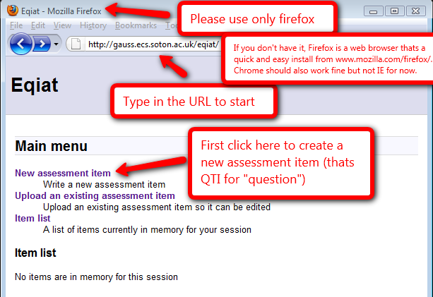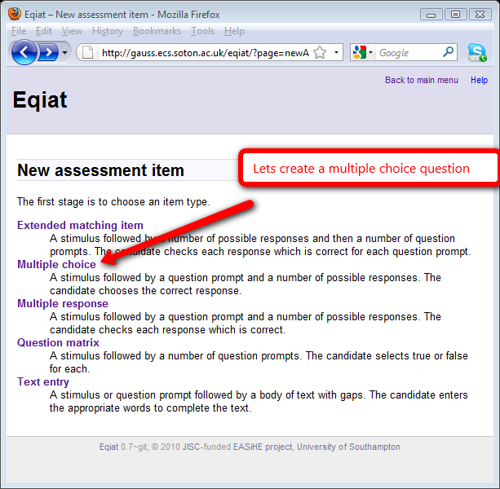

Before we begin, the following screenshot is an example of a multiple choice question created using Eqiat, to give you an example of what can be created.

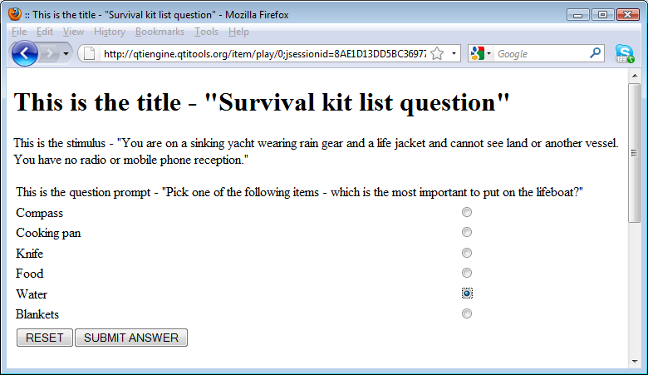

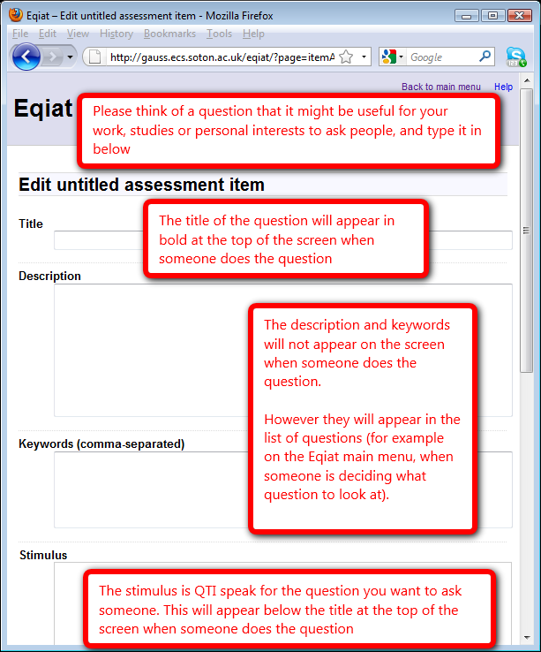
Note: Just below this screen there is an option that says:

Item type
- Multiple choice (choose one answer)
- Multiple response (choose all appropriate answers)

However there is no need to change this as you have already selected this option on the previous screen.
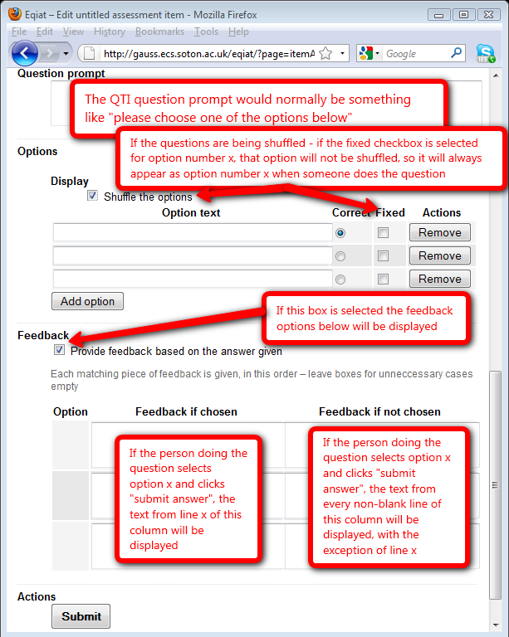
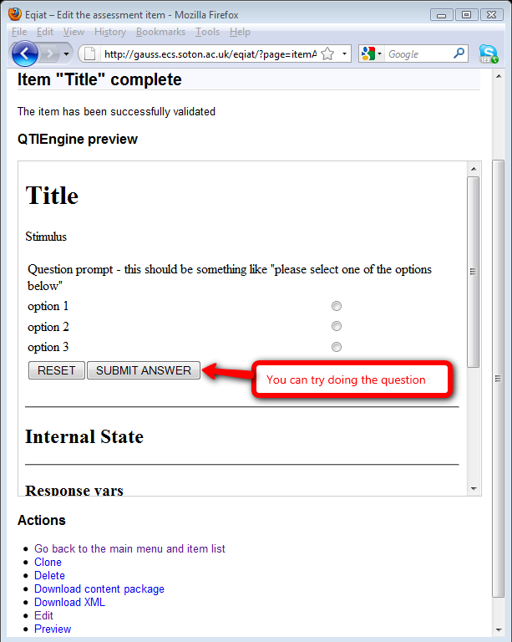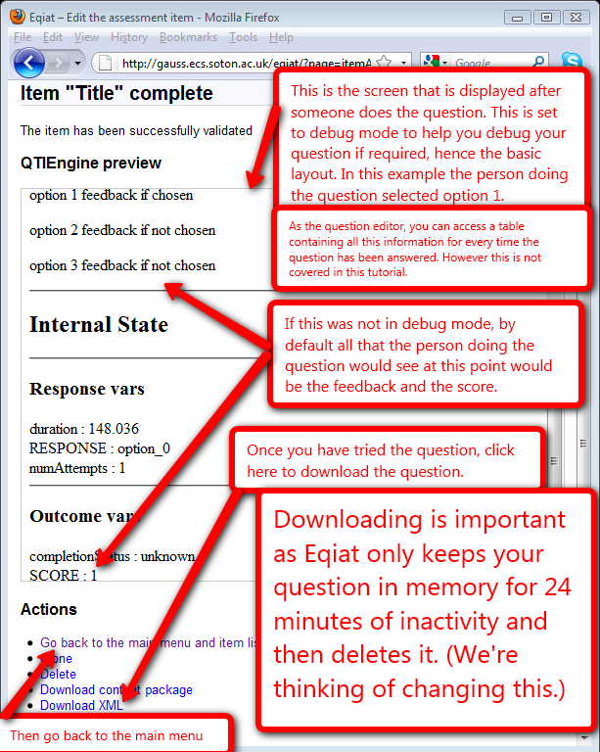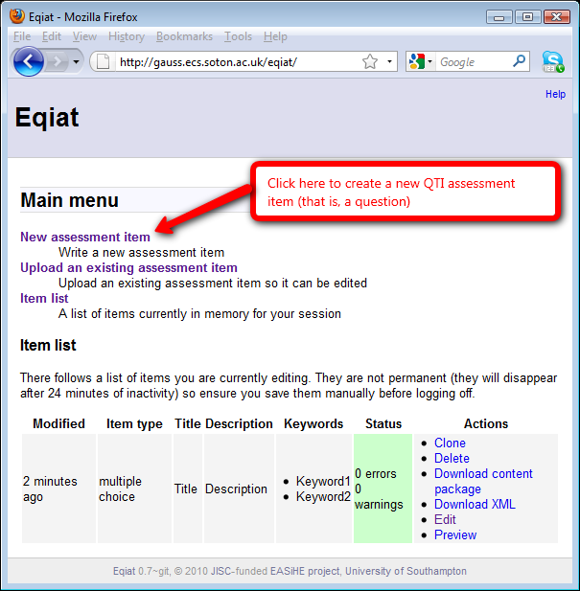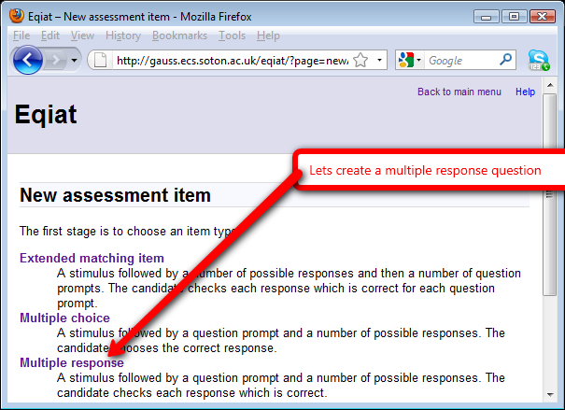

Before we begin, the following screenshot is an example of a multiple response question created using Eqiat, to give you an example of what can be created.

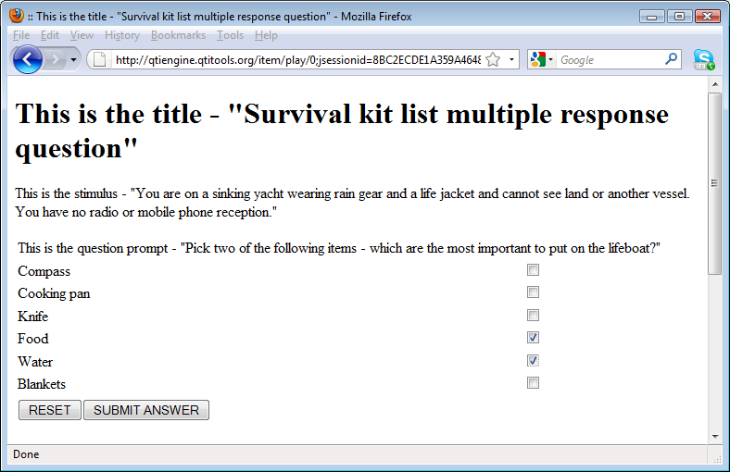

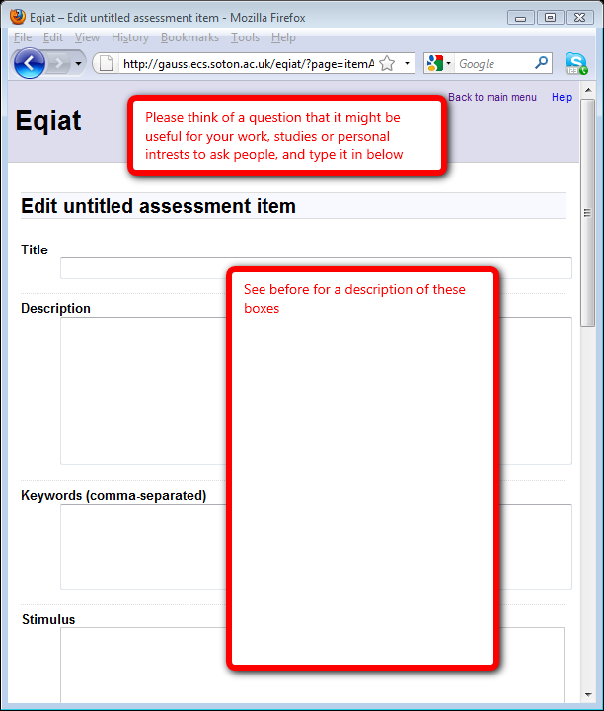
Note: Just below this screen there is an option that says:

Item type
- Multiple choice (choose one answer)
- Multiple response (choose all appropriate answers)

However there is no need to change this as you have already selected this option on the previous screen.

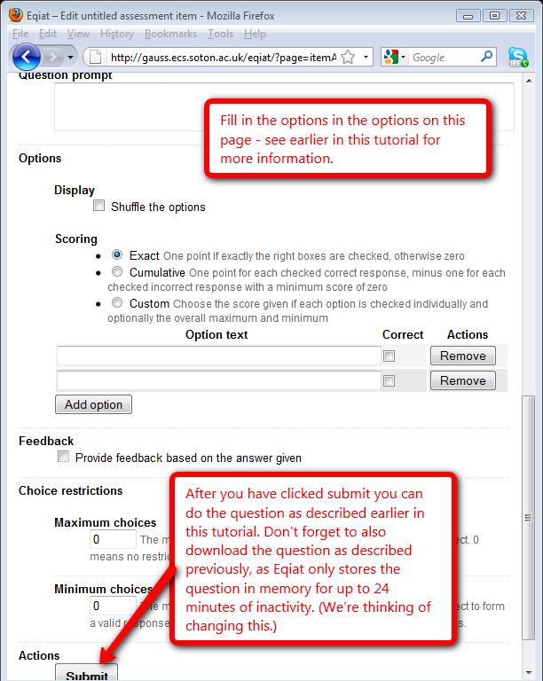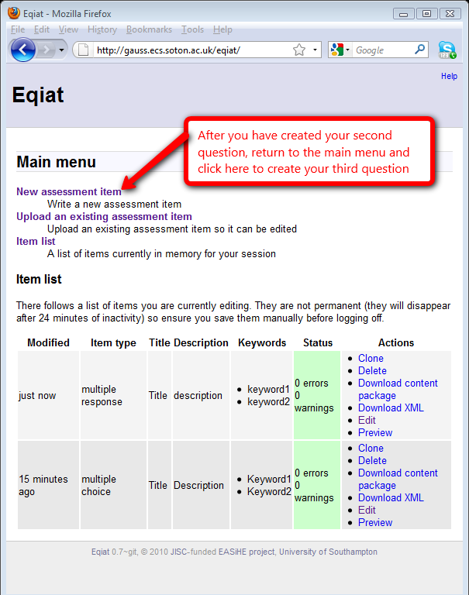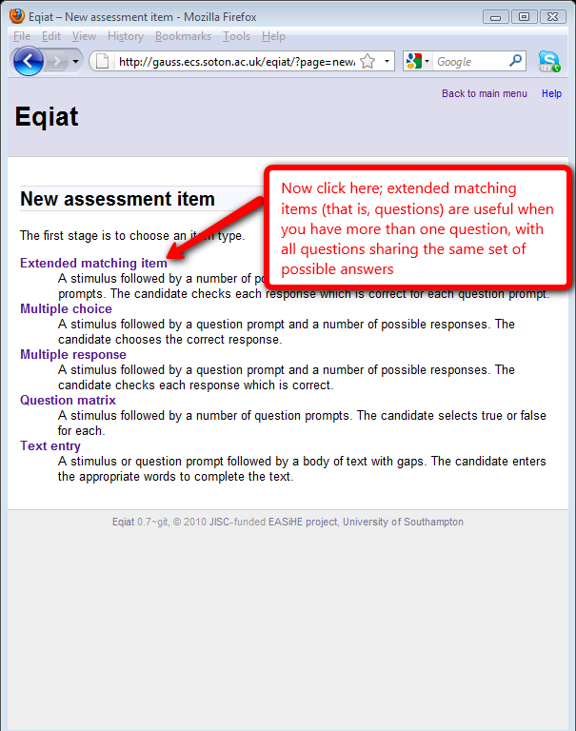

Before we begin, the following screenshot is an example of an extended matching question created using Eqiat, to give you an example of what can be created.

